The from open way show way lik background and all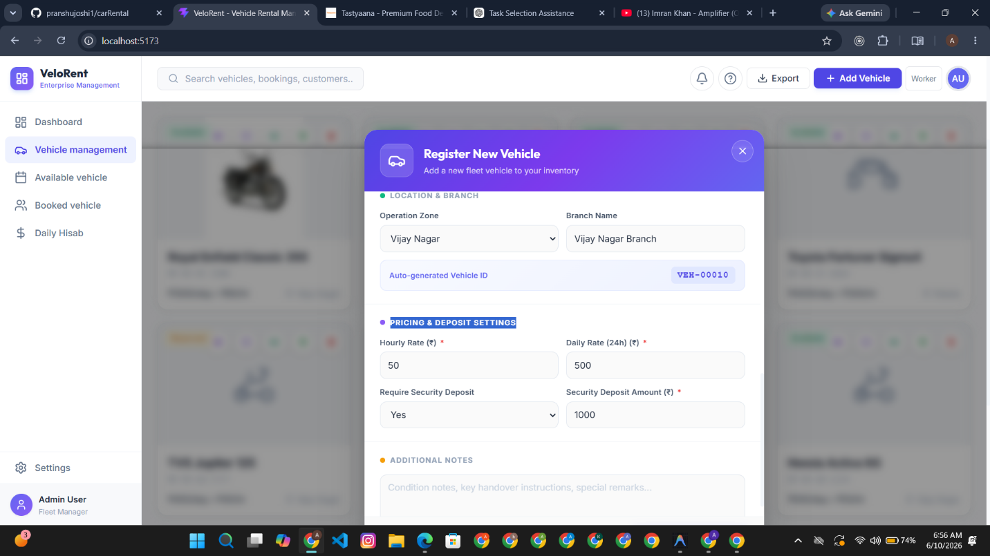
the from show we want 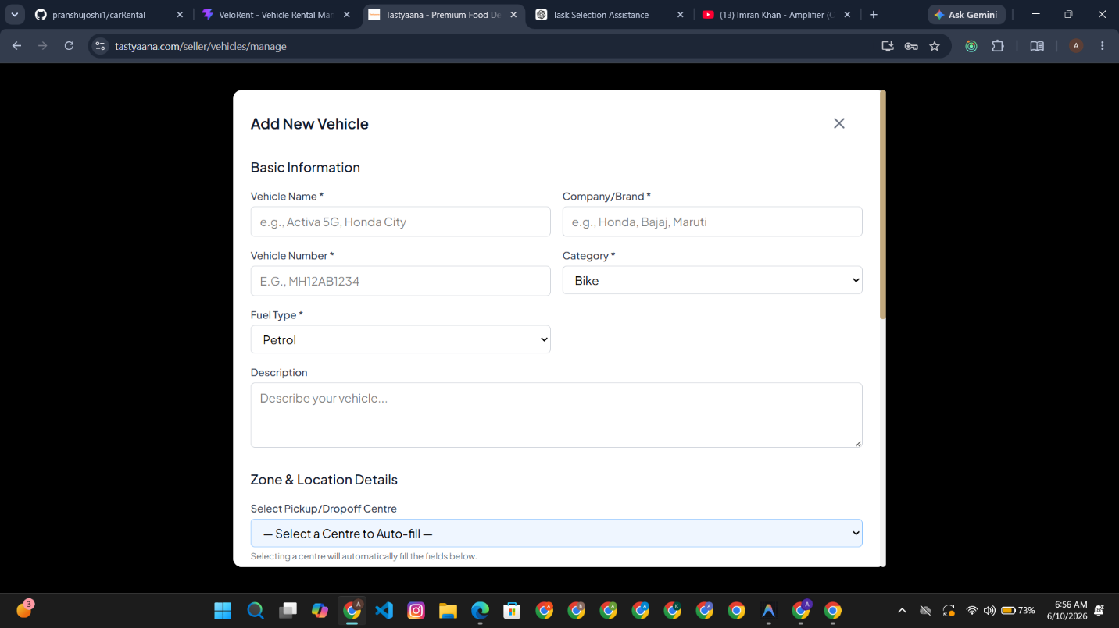
vehicle history and vehicle configrurationn open section how we wantki ye fullnns screen per aae side bar ke side and nevaber ke niche 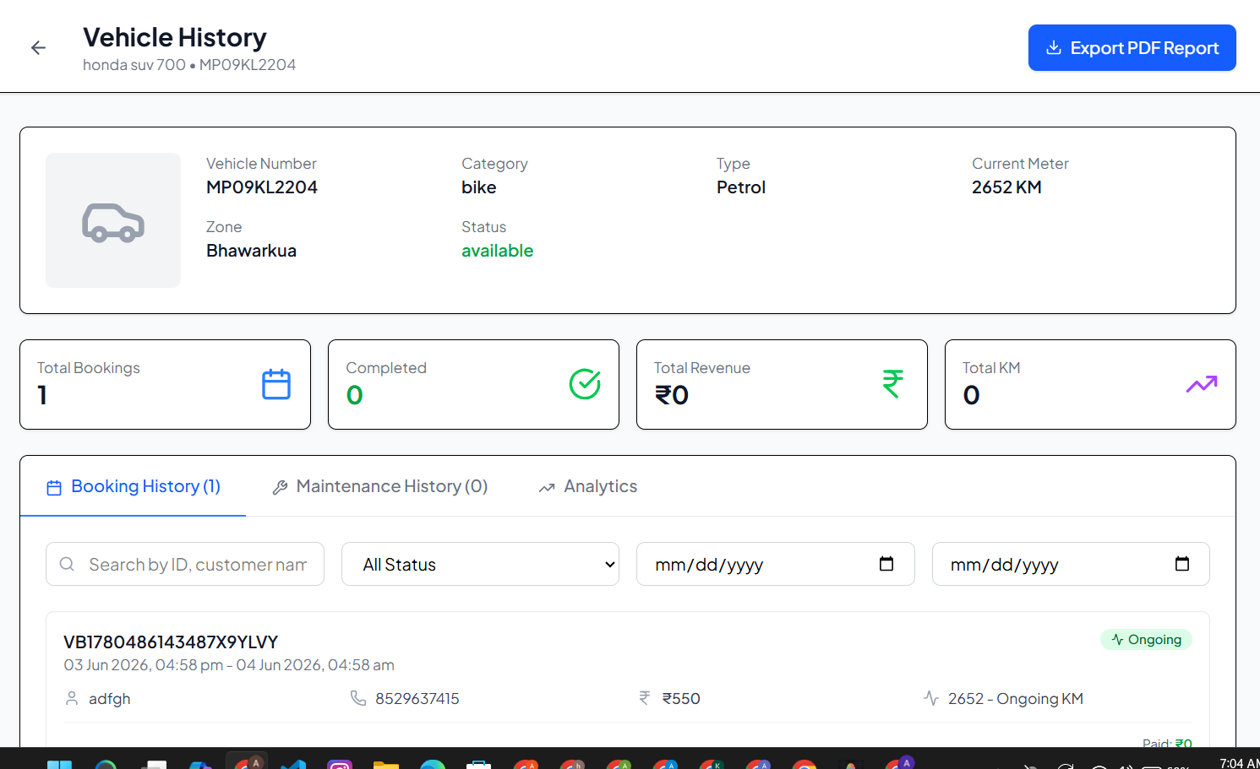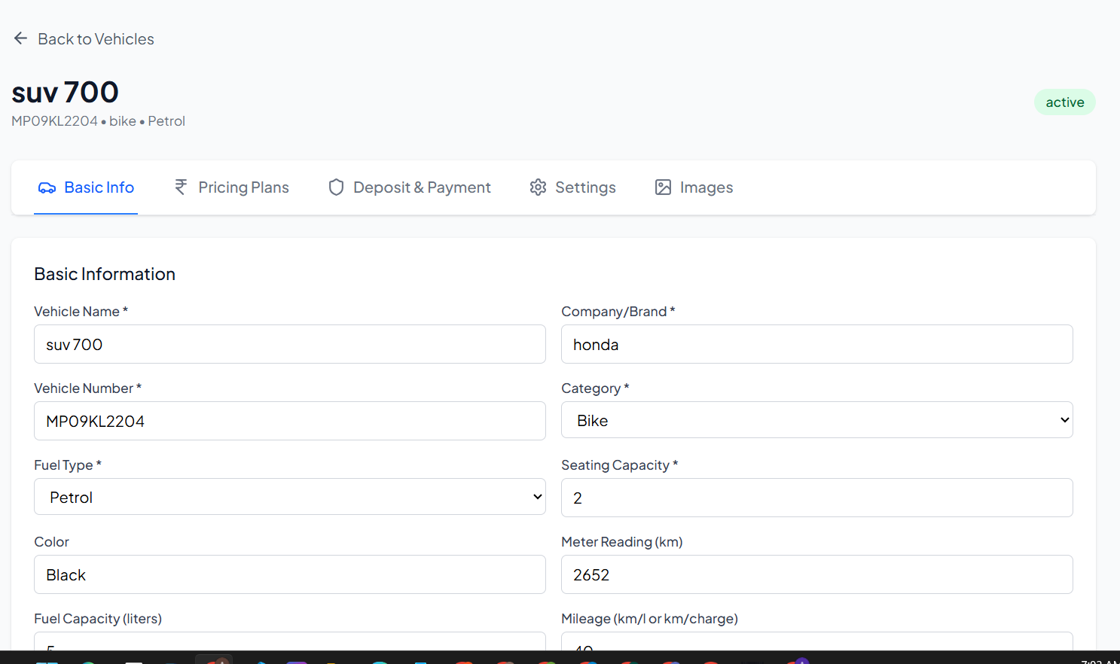
location delete avaiable form open ho to full backgournd black ho jae and ek hi stic jagah per open ho scroller na ho main screen
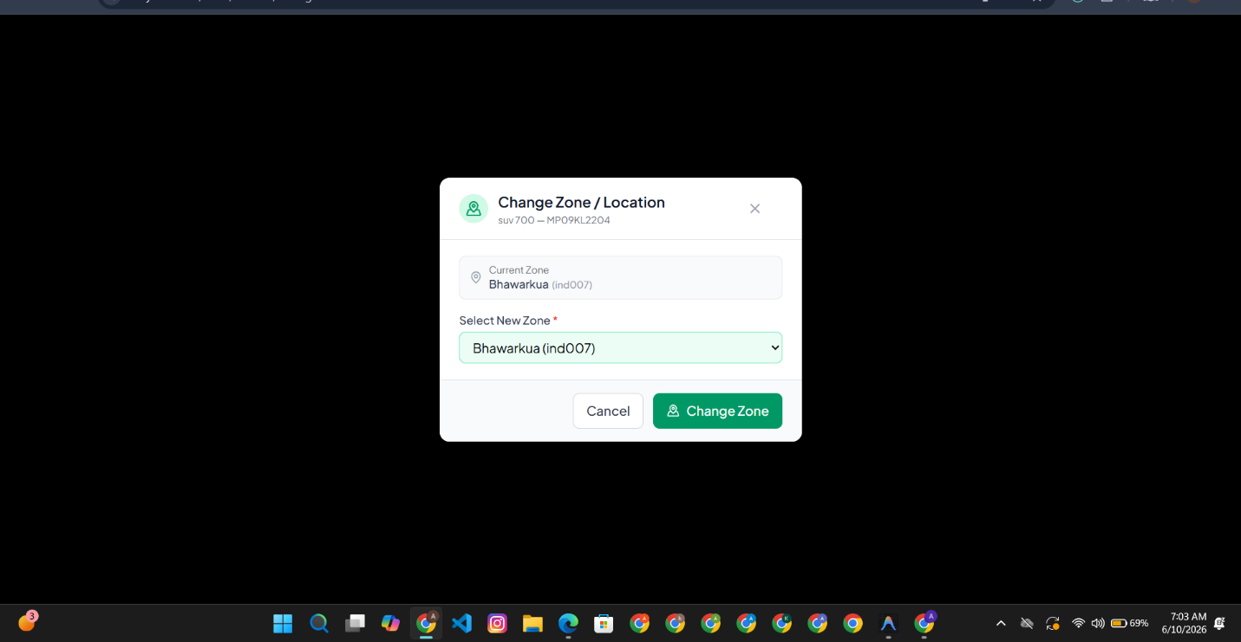
main grid and filter 3 cards chahiye bas 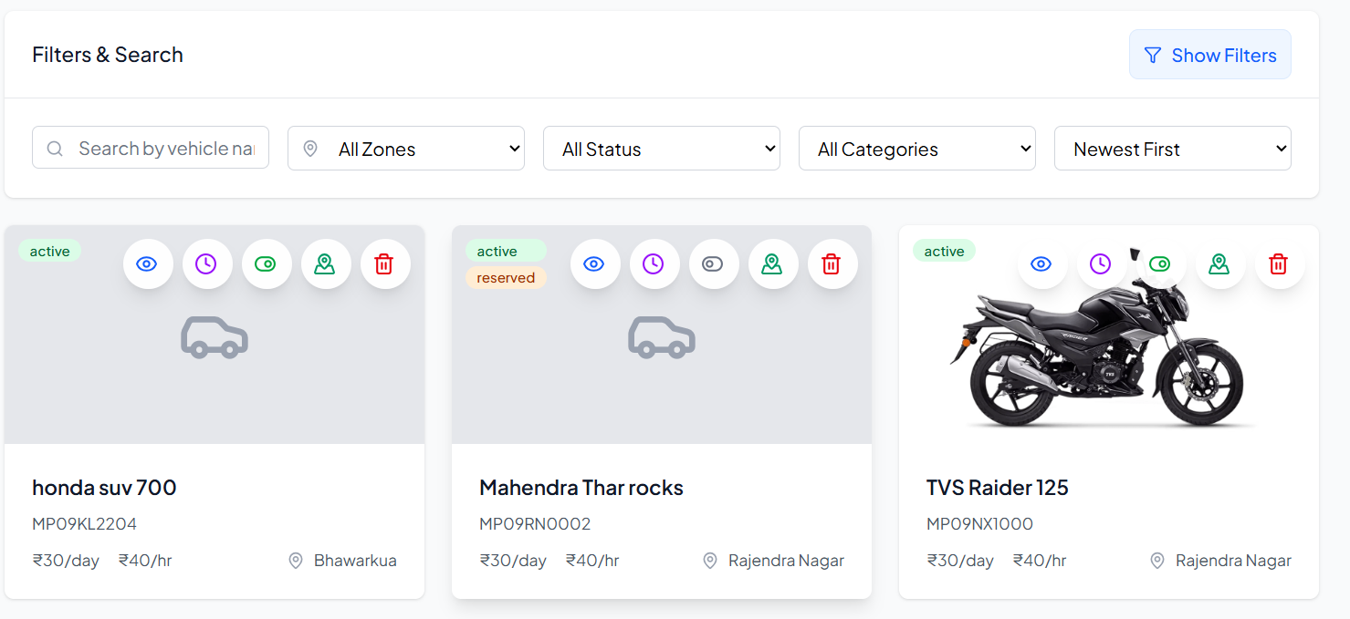
add vehicle from in responsivenss
